

DEPARTMENT OF ARTIFICIAL INTELLIGENCE

A PROJECT REPORT ON
A POLICY-BOUNDED AGENTIC FRAMEWORK FOR AUTONOMOUS GOVERNANCE OF CLOUD DATA PIPELINES

Submitted by
B SAI KRISHNA [CB.SC.U4AIE24308]
I MAHALAKSHMI [CB.SC.U4AIE24322]
SRI HARINI MP [CB.SC.U4AIE24358]
VIGNES VM [CB.SC.U4AIE24359]

TABLE OF CONTENTS

1. INTRODUCTION 1
1.1 Background 1
1.2 Motivation 1
1.3 Problem Statement 2
1.4 Objectives 2
1.5 Research Questions 2
1.6 Scope of the Project 3
1.7 Contributions 3
1.8 Organization of the Report 3
2. LITERATURE SURVEY 4
2.1 The Base Architecture 4
2.2 Workflow Orchestration and Heuristic Automation 4
2.3 LLM Agents for Cloud Operations 4
2.4 Evaluation Validity for LLM Agents 5
2.5 Graduated Autonomy and Runtime Policy 5
2.6 Adversarial Evaluation and Decision Quality 5
2.7 Fault Injection and Statistical Methods 5
2.8 Research Gap 6
3. SYSTEM ANALYSIS AND REQUIREMENTS 7
3.1 Existing System 7
3.2 Proposed System 7
3.3 Feasibility Study 8
3.4 Hardware and Software Requirements 8
3.5 Functional Requirements 9
3.6 Non-Functional Requirements 9
4. SYSTEM DESIGN 10
4.1 Architecture Overview 10
4.2 Problem Formulation 11
4.3 Action Contract 12
4.4 Control Loop Design 12
4.5 Database Design 13
4.6 Data Flow 13
5. IMPLEMENTATION 14
5.1 Technology Stack 14
5.2 Project Structure 14
5.3 Data Plane and Telemetry 15
5.4 Agents and the LLM Client 15
5.5 Action Contract 15
5.6 Policy Engine 15
5.7 Execution and Write-Ahead Audit 16
5.8 Fault Injection and Experiment Harness 16
5.9 Analysis and Artifact Generation 16
5.10 Operator API and Dashboard 16
5.11 Cloud Deployment on Microsoft Azure 17
6. TESTING AND VALIDATION 17
6.1 Testing Strategy 17
6.2 Unit Testing 17
6.3 Policy Testing 17
6.4 Integration Testing 17
6.5 Static Analysis 17
6.6 Adversarial Validation 17
6.7 Pilot Runs 18
7. RESULTS AND DISCUSSION 19
7.1 Experimental Setup 19
7.2 RQ1: Comparison with Static Orchestration 19
7.3 RQ2: Comparison with Non-LLM Automation 21
7.4 RQ3: Decision Quality 21
7.5 Per-Scenario Behaviour 22
7.6 RQ4: Mock Versus Live Evaluation 23
7.7 LLM Accounting 23
7.8 Sensitivity Analysis 24
7.9 RQ5: Adversarial Containment 25
7.10 Lessons Learned 26
7.11 Limitations 26
8. CONCLUSION AND FUTURE WORK 27
8.1 Conclusion 27
8.2 Future Work 27
REFERENCES 28
APPENDIX A: REPRODUCTION GUIDE 30

01
CHAPTER ONE
1. INTRODUCTION
1.1 Background
Modern organizations move data through pipelines that ingest, transform, and store it for analytics. These pipelines fail in ordinary ways. An upstream schema changes a column's type, a source stalls, a co-tenant starves the pipeline of compute, or ingress bursts past capacity. An empirical study of real pipelines identifies 41 distinct factors behind such quality and reliability failures [1]. In most deployments the remedy is still an on-call engineer, and the time that engineer needs to respond often accounts for much of the recovery time.
Workflow orchestrators such as Apache Airflow schedule, retry, and alert, but they do not reason about failures their authors did not anticipate. Large language model (LLM) agents could shorten the loop between failure and recovery, and agent systems for cloud incidents already run in production [2]–[4]. Most of them stop at a recommended diagnosis.
1.2 Motivation
Once an agent may also act on production infrastructure, a governance question arises: what limits the actions it can take? A recent proposal [5] answers with four bounded agents for monitoring, optimization, schema management, and recovery. Each agent emits only a structured action proposal, and a declarative policy engine must approve the proposal before anything executes. Against static orchestration, the authors report reductions of up to 45% in recovery time, about 25% in cost, and more than 70% in manual interventions. This project asks whether those claims survive a careful, reproducible evaluation with a real model in the loop.
1.3 Problem Statement
Four gaps separate the claims of the base proposal from the evidence offered for them:
- Evaluation path: the study gives too little implementation detail to identify the model-in-the-loop condition behind its headline figures, although simulated environments are known to inflate agent performance [6]–[8].
- Baselines: the only comparator is static orchestration, even though mature non-LLM automation already runs at production scale [9].
- Adversarial testing: the safety case rests on the policy gate, but the bound is asserted rather than tested against an adversary [10]–[12].
- Statistics and generality: no confidence intervals, effect sizes, run counts, or cross-model results are reported [13], [14].
The problem addressed by this project is therefore to build the policy-bounded agentic system and to measure, with appropriate baselines, statistics, and an adversarial test, how much of the claimed benefit holds when a real model drives the agents.
1.4 Objectives
- Design and implement a seven-layer, policy-bounded agentic framework for cloud data pipeline governance.
- Gate every agent action through declarative Open Policy Agent policies with a fail-safe default and a write-ahead audit trail.
- Build a reproducible, seeded fault-injection and experiment harness with per-run provenance.
- Evaluate the system with a live LLM against static orchestration and two non-LLM baselines, with confidence intervals and effect sizes.
- Quantify how a deterministic mock changes the conclusions relative to the live model.
- Test the policy gate against a generated adversarial corpus graded by an independent oracle.
1.5 Research Questions
- RQ1: With a real model in the loop, does the full agent system outperform static orchestration on recovery time, cost, and manual interventions?
- RQ2: Does it outperform cheap non-LLM automation, or only a slow human?
- RQ3: Does it act correctly, and not merely quickly?
- RQ4: Do the answers to RQ1–RQ3 change when the model is replaced by a deterministic mock?
- RQ5: Does the policy gate contain adversarial proposals when judged against an oracle that is independent of the policy code?
1.6 Scope of the Project
The project covers the complete software system, a single-host containerized testbed, four injected fault scenarios, eight configurations, and a live campaign with one model family. A cross-model harness, a production trust core (graduated autonomy, kill switch, blast-radius cap), and an enterprise governance layer are implemented and unit-tested but were not exercised in the evaluated campaign; the report describes them as architecture rather than as results.
1.7 Contributions
- A live-model evaluation of eight configurations across four fault scenarios in a 560-run campaign with per-run provenance and billing-accurate LLM accounting.
- Explicit non-LLM baselines and a decision-quality metric that test whether the agent system beats cheap automation and whether it acts correctly.
- An adversarial evaluation of the policy gate against an independently written oracle.
- A disclosed cost model with closed-form sensitivity analyses, together with an account of where its metered term falls short.
- Seven production-hardening lessons drawn from defects the system actually exhibited.
1.8 Organization of the Report
Chapter 2 surveys the related literature. Chapter 3 analyzes the existing system and states the requirements. Chapter 4 presents the system design, and Chapter 5 describes the implementation. Chapter 6 covers testing and validation. Chapter 7 reports and discusses the experimental results, and Chapter 8 concludes the report and outlines future work.
02
CHAPTER TWO
2. LITERATURE SURVEY
This chapter reviews four bodies of work: LLM agents for cloud operations, the validity of LLM agent evaluations, runtime governance of agent actions, and the non-LLM automation against which such agents should be measured.
2.1 The Base Architecture
The base proposal [5] describes a data plane, a policy plane, and an agentic control plane. Four bounded agents share the control plane, and each produces only a validated action proposal. Its evaluation compares the system with a static-orchestration baseline across injected failures. This project follows the same decomposition and records every design choice the description leaves open.
2.2 Workflow Orchestration and Heuristic Automation
Workflow orchestrators such as Airflow, Prefect, and Dagster are execution-centric: they schedule, retry, and alert. Automation driven only by resource signals nonetheless achieves a great deal at production scale. Google's Autopilot [9], a heuristic autoscaler covering a large share of Google's fleet, uses no LLM, which makes such automation a legitimate comparator rather than a strawman.
2.3 LLM Agents for Cloud Operations
Reasoning-and-acting loops [15] are the general pattern behind agents that observe a system and propose actions. For root-cause analysis, RCACopilot [2] and RCAgent [3] apply tool-augmented LLMs to production incidents at Microsoft and Alibaba Cloud, and OpsAgent [4] is a multi-agent incident-management system in production at Lenovo. These systems mostly recommend; the design studied here also executes, which is what makes a policy gate necessary.
2.4 Evaluation Validity for LLM Agents
A growing literature studies the gap between simulated and real evaluation of LLM agents. One framing decomposes the gap into observation, action, transition, and reward mismatches [6]. Empirical studies find that LLM-simulated users are excessively cooperative and inflate agent success [7], and that reliability drops under production-like stress such as tool faults and rate limits [8]. High-fidelity benchmarks such as TheAgentCompany [16] show low completion of consequential tasks, and a survey of agentic benchmarks finds that none meets basic procedural-validity criteria for public-sector deployment [17].
2.5 Graduated Autonomy and Runtime Policy
Graduated autonomy and a durable kill switch build on the game-theoretic treatment of shutdown incentives [18]. A related framework separates an agent's permitted autonomy level from its capability level [19]. The policy gate in this project runs on Open Policy Agent [20]; one critique argues that Rego-style languages are not expressive enough for agentic governance [12], while ActGov [21] validates every tool call against an SMT-verified policy engine, which is functionally the same per-action gate.
2.6 Adversarial Evaluation and Decision Quality
AgentDojo [10] and the Agent Security Bench [11], which reports attack success rates of up to 84.3% against weak defenses, are the extensible benchmarks closest to the corpus used here. Resolving an incident quickly is not the same as resolving it correctly: AIOpsLab [22] evaluates detection, localization, and mitigation, and OpenSec [23] finds poor calibration in frontier models. Cross-model studies report large behavior shifts across models and providers [13], [14].
2.7 Fault Injection and Statistical Methods
Deliberate fault injection is established practice [24]. The statistical analysis in this project uses bootstrap resampling [25], the Mann–Whitney [26] and Wilcoxon [27] tests, Holm's correction [28], Cliff's δ [29], and Wilson intervals [30].
Table 1: Summary of related work and its relation to this project
Work | Focus | Relation to this project
Base proposal [5] | Policy-gated agents for pipelines | Architecture implemented and evaluated here
Autopilot [9] | Heuristic autoscaling at scale | Motivates non-LLM baselines
RCACopilot [2], RCAgent [3] | LLM root-cause analysis | Diagnose only; this system also acts
OpsAgent [4] | Multi-agent incident management | Industrial practice, same direction
Sim-to-real studies [6]–[8] | Simulation inflates agent results | Context for the mock-vs-live finding
AgentDojo [10], ASB [11] | Agent security benchmarks | Closest to the adversarial corpus
ActGov [21] | SMT-verified action gating | Same per-action gate concept
AIOpsLab [22], OpenSec [23] | Decision quality of cloud agents | Motivates the correct-mitigation metric

2.8 Research Gap
Prior work shows that agents can fail under live or adversarial conditions, but no study measures, within one controlled campaign, how far the evaluation path alone moves the conclusions about a policy-gated pipeline agent. This project fills that gap and, in addition, tests the policy bound adversarially and compares against explicit non-LLM baselines.
03
CHAPTER THREE
3. SYSTEM ANALYSIS AND REQUIREMENTS
3.1 Existing System
In the existing practice, pipelines run under static orchestration: fixed allocations, predefined retries, and human-initiated remediation, with autoscaling disabled. When a fault occurs, an alert reaches an on-call engineer, who diagnoses and repairs it by hand. The base proposal adds LLM agents but evaluates them only against this static baseline and without disclosing whether a real or simulated model produced its numbers.
3.1.1 Limitations of the Existing System
- Recovery time is dominated by human response time.
- Static allocation over-provisions resources and wastes cost.
- Agent-based proposals lack independent safety testing, credible baselines, and statistical reporting.
- Evaluations that use a simulated model may not transfer to a live deployment.
3.2 Proposed System
The proposed system is a seven-layer, policy-bounded agentic framework. Four bounded agents observe telemetry and emit only typed action proposals; a declarative policy gate decides each proposal from a context the system builds itself; allowed actions execute through a write-ahead audit trail; and everything else escalates to a human. The system is accompanied by a reproducible experiment harness that evaluates it against static orchestration and two non-LLM baselines, with a live model and with a deterministic mock.
3.2.1 Advantages of the Proposed System
- Agents never emit or execute code; every action is validated, policy-gated, and audited.
- Fail-safe defaults: an unreachable policy engine or an unmatched proposal escalates to a human.
- Every reported result is regenerated from committed per-run data with provenance checks.
- The safety bound is tested against an independent oracle rather than asserted.
3.3 Feasibility Study
3.3.1 Technical Feasibility
All components are open source and run in containers on a single laptop-class machine: PostgreSQL, Redpanda, Apache Airflow, and Open Policy Agent, with a Python 3.11 control plane. The live model is reached through an OpenAI-compatible endpoint.
3.3.2 Economic Feasibility
The software stack has no licence cost. The live campaign made 703 model calls and used 975,570 tokens across 240 live runs, well within a modest research budget; all tests and the default configuration use a mock model with zero API calls.
3.3.3 Operational Feasibility
The system attaches to an existing orchestrator through a connector boundary, supports shadow and approval modes before autonomous operation, and exposes an operator API and dashboard, so it can be introduced gradually into an existing operations team.
3.4 Hardware and Software Requirements
Table 2: Testbed, software versions, and fixed experimental parameters
Item | Setting
Host | One Apple M2 machine (arm64), 8 cores, 8 GB memory, macOS 15.7.2; runs strictly sequential
Software | Docker 29.6.1; PostgreSQL 16.6; Redpanda v24.2.18; Apache Airflow 2.10.5 (Python 3.11); OPA 0.68.0
Batch data | Downscaled TPC-DS-derived synthetic fact table, 20,000 rows
Live model | Reasoning agents: nvidia/nemotron-3-ultra-550b-a55b; monitoring: nvidia/nemotron-3-super-120b-a12b; OpenAI-compatible endpoint, temperature 0
LLM budget | 60 calls and 150,000 tokens per run
Timing | 120 s warm-up, 300 s control loop, 5 s settle; control tick 2 s (default 15 s)
Human model | Log-normal delay, median 360 s, σ = 0.5
Cost model | Static allocation 8 units, right-sized 3 units, horizon 300 s; 0.05 per compute unit-second, 0.01 per GB-hour
Baseline latencies | rule_based resolves covered faults 30 s after detection; autoscale 20 s
Policy limits | Rate limit of 5 actions per agent per 10 minutes; default budget 100 units per run

3.5 Functional Requirements
- Collect pipeline telemetry (task runs, resource usage, failure events, freshness, cost) into a central store.
- Detect anomalies and record failure events with detection timestamps.
- Let each agent propose only actions from its own allowlist, as a validated structured object.
- Evaluate every proposal against rate-limit, cost-budget, recovery-approval, and schema-compatibility policies.
- Execute allowed actions on Airflow and PostgreSQL, and escalate denied or unmatched ones to a human.
- Record an intent row before execution and the outcome after it.
- Inject reproducible, seeded faults and run experiment matrices with per-run provenance.
- Generate every table, figure, and reported number from the committed run data.
3.6 Non-Functional Requirements
- Safety: fail toward the human on any policy or infrastructure failure.
- Determinism: every stochastic component takes an explicit seed; the model runs at temperature zero.
- Auditability: every action, verdict, and outcome is persisted.
- Reliability: bounded retries for database and orchestrator calls; supervised, resumable campaigns.
- Maintainability: full type hints, linting, static type checking, and more than 80% unit-test coverage.
- Security: no secrets in code; credentials only through environment configuration.
04
CHAPTER FOUR
4. SYSTEM DESIGN
4.1 Architecture Overview
The system is organized in seven layers, shown in Figure 1. Layers 1 and 2 form the data plane and its telemetry, layer 3 holds the four bounded agents, layer 4 is the policy gate, and layer 5 executes and audits whatever the gate allows. Layers 6 and 7, orchestration and enterprise governance, extend the base design. Dashed boxes mark components that are implemented but were not exercised in the evaluation.
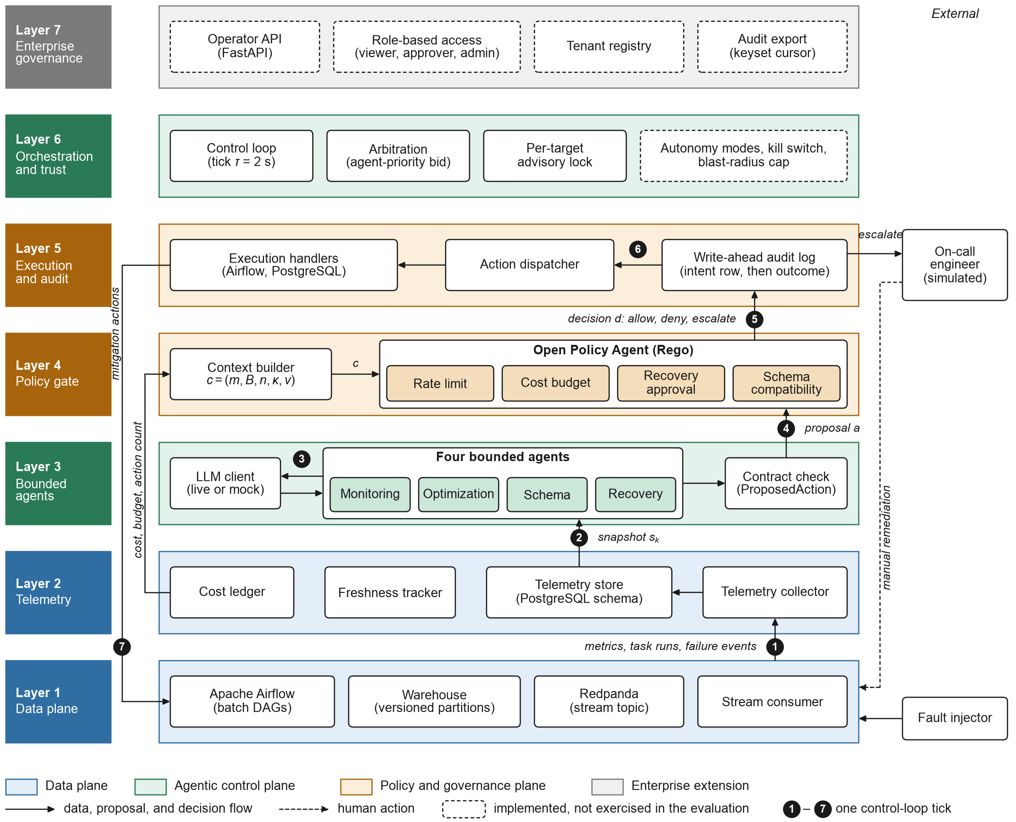
Figure 1: Seven-layer system architecture
Table 3: Layers of the architecture
Layer | Components | Role | Evaluated
1 Data plane | Airflow, warehouse, Redpanda, stream consumer | Batch and streaming ingestion | Yes
2 Telemetry | Collector, telemetry store, freshness, cost ledger | Observability and metrics | Yes
3 Agents | Monitoring, optimization, schema, recovery; LLM client | Observe, reason, propose | Yes
4 Policy gate | Context builder, OPA with four policy packs | Allow, deny, escalate | Yes
5 Execution | Write-ahead audit log, dispatcher, handlers | Execute and audit | Partly
6 Orchestration | Control loop, arbitration, locks, trust core | Drive the loop, resolve conflicts | Partly
7 Governance | Operator API, RBAC, tenants, audit export | Multi-tenant operation | No

4.2 Problem Formulation
A pipeline emits a telemetry snapshot s_k at each control tick k. A fault f is injected at time t_f, detected at t_d, and resolved at t_r, either by an executed mitigation or by the on-call engineer. Each enabled agent g proposes an action a = (g, type, target, params, justification, confidence). A policy gate G decides each proposal from a context c = (m, B, n, κ, v): the projected marginal cost m, the remaining budget B, the number n of actions the proposing agent has recorded in the last ten minutes, the schema-compatibility class κ, and a flag v indicating whether a prior version exists.
4.2.1 Gate Semantics
The rate limit is applied before any agent-specific policy:
G(a, c) = DENY if n ≥ n_max, n_max = 5 (4.1)
A scaling action passes the cost policy only if
m ≤ 0 or m ≤ B (4.2)
so a scale-down always passes. Rollback requires v, a schema change requires a backward-compatible κ, and any proposal that matches no policy or cannot be evaluated escalates.
4.2.2 Metrics
MTTR(r) = t_r − t_d (4.3)
C(r) = C_meas(r) + ρ_c · u_π · T_h (4.4)
D(r) = 1[ executed mitigation ∈ A*(f) ] (4.5)
Here C_meas is the metered compute and storage cost, ρ_c = 0.05 per unit-second, u_π is the allocation held over the horizon T_h = 300 s (3 units for right-sizing configurations, 8 otherwise), and A*(f) is the set of accepted mitigations for the fault. The evaluation-validity question compares the median of a metric under a live model and under a mock through the divergence ratio
R_x = x̃_live / x̃_mock (4.6)
4.3 Action Contract
An agent's only output is a ProposedAction. A typed schema rejects any action type outside the agent's allowlist and any scaling target that is not an integer of at least one; invalid output degrades the agent's turn to no_action and is counted.
Table 4: Action types allowed for each agent
Agent | Allowed action types
Monitoring | raise_anomaly, escalate, no_action
Optimization | scale_workers, adjust_pool_slots, reprioritize_pipeline, no_action
Schema | allow_compatible, apply_mapping, quarantine_partition, block_ingestion, no_action
Recovery | retry_with_backoff, replay, rollback, partial_recompute, escalate_to_human, no_action

4.4 Control Loop Design
Each control tick performs the following steps:
- Record a heartbeat and return immediately if the kill switch is engaged.
- Run the monitoring agent to detect faults and stamp the detection time.
- If an unresolved fault exists, let each enabled reactive agent (schema, recovery, optimization) observe and reason; invalid output becomes no_action.
- For each contested target, keep the proposal with the highest (agent priority, confidence); priority ranks recovery above schema above optimization.
- For each winning proposal, skip it if the target lock is held or the blast-radius cap is reached.
- Evaluate the policy decision, commit an intent row, execute the action if allowed or escalate it, and update the audit row with the outcome.
4.5 Database Design
All state is held in PostgreSQL in three schemas created by idempotent migrations.
Table 5: Database schemas and tables
Schema | Tables | Purpose
telemetry | task_runs, pipeline_metrics, schema_versions, resource_usage, failure_events, agent_actions, manual_interventions, cost_ledger, action_approvals | Observability, audit trail, and every experimental metric
warehouse | partition_versions, stream_aggregates, quarantine_events | Versioned batch partitions and streaming aggregates
control | desired_state | Desired worker counts, schema mappings, and other control settings

4.6 Data Flow
Raw metrics, task runs, and failure events flow from the data plane into the telemetry store. A snapshot s_k feeds the agents, which call the LLM client and pass their proposals through the contract check. The context builder reads cost, budget, and action counts from telemetry and passes the context c to OPA, whose decision d goes to the write-ahead audit log. The dispatcher then routes allowed actions to the Airflow and PostgreSQL handlers, whose mitigation actions act back on the data plane, while escalations go to the on-call engineer.
05
CHAPTER FIVE
5. IMPLEMENTATION
5.1 Technology Stack
Table 6: Technology stack
Concern | Technology
Language and contracts | Python 3.11, pydantic v2 (typed, validated data at every boundary)
Data plane | Apache Airflow 2.10.5 (batch), Redpanda v24.2.18 (streaming), PostgreSQL 16.6
Policy engine | Open Policy Agent 0.68.0 with Rego policies and policy unit tests
LLM access | OpenAI-compatible, Anthropic, and Gemini clients; deterministic mock client
Operator surface | FastAPI, Uvicorn, Jinja2 dashboard
Analysis | pandas, SciPy, matplotlib
Quality and packaging | ruff, mypy, pytest, uv, Docker Compose, Helm

5.2 Project Structure
The control plane is a Python package of 104 modules (about 11,700 lines) organized by responsibility.
Table 7: Main modules of the implementation
Module | Responsibility
contracts | ProposedAction and telemetry data contracts
agents | Monitoring, optimization, schema, and recovery agents; anomaly detection
llm | Live and mock model clients, prompts, budget and accounting
policy | Context builder, policy gate, executor and handlers
orchestrator | Control loop, arbitration, advisory locks, soak runs
dataplane / telemetry | Batch and streaming pipelines; collector, freshness, cost ledger
chaos | Seeded fault scenarios, injector, CPU stressor
experiments | Configurations, baselines, run harness, campaign supervisor, decision quality
eval | Adversarial corpus, independent oracle, cross-model harness
analysis | Statistics, sensitivity analysis, paper tables and figures
server / ops | Operator API, dashboard, metrics, health, compliance, backup

5.3 Data Plane and Telemetry
A batch DAG in Apache Airflow ingests a downscaled TPC-DS-derived table into versioned warehouse partitions; a streaming consumer reads a Redpanda topic with a resizable worker pool. A telemetry collector polls Airflow and the container runtime and writes task runs, resource usage, and pipeline metrics; a cost module integrates worker and slot counts into a per-run cost ledger.
5.4 Agents and the LLM Client
Each agent turns a telemetry snapshot into a prompt, calls the model client, and parses the reply into a ProposedAction. The live client calls a remote model at temperature zero; the mock client returns deterministic, rule-based proposals so that all tests run with zero API calls. Identical snapshots within a run are served from a cache, and the accounting counts real calls, cache hits, degraded proposals, invalid outputs, tokens, and latency at the moment a call is or is not made.
5.5 Action Contract
The contract is a pydantic model with validators for the per-agent allowlist and for positive integer scaling targets:
class ProposedAction(BaseModel):
action_id: UUID = Field(default_factory=uuid4)
agent: AgentName
action_type: str
target: str
params: dict[str, Any] = Field(default_factory=dict)
justification: str = Field(max_length=1200)
confidence: float = Field(ge=0, le=1)

@model_validator(mode="after")
def _action_type_allowed_for_agent(self):
if self.action_type not in ACTION_TYPES[self.agent]:
raise ValueError("action type not allowed for agent")
return self
5.6 Policy Engine
Four Rego policy packs implement the gate, and a main policy defaults to escalation when no pack matches. The rate-limit pack is shown below:
package acde.rate_limit
import rego.v1

limit := 5
exceeded if input.context.actions_last_10min >= limit

result := {
"allowed": false, "escalate": false,
"reason": sprintf("rate limit: %v actions in the last 10 minutes",
[input.context.actions_last_10min]),
"policy_id": "rate_limit",
} if { exceeded }
5.7 Execution and Write-Ahead Audit
The executor commits an intent row carrying the policy verdict before it runs any side effect and updates the row with the outcome afterward, so a crash mid-action leaves a durable record. A dispatcher routes each allowed action type to a handler that triggers DAG runs, clears tasks, or patches pool slots on Airflow, or performs rollback, quarantine, schema mapping, and desired-state updates on PostgreSQL. Escalations are resolved by a seeded log-normal simulator that stands in for the on-call engineer.
5.8 Fault Injection and Experiment Harness
The injector reproduces four scenarios from a seed: schema drift, upstream delay, resource contention (real CPU stress), and ingress burst. The run harness resets run-scoped telemetry, warms up for 120 s, injects the fault, drives the configuration's response, settles, harvests the metrics, and appends a provenance record to the run manifest. A campaign supervisor runs the three arms sequentially, resumes after interruption, and enforces token ceilings.
5.9 Analysis and Artifact Generation
The analysis package computes medians, bootstrap intervals, Cliff's δ, Holm-corrected Mann–Whitney tests, Wilson intervals, and closed-form sensitivities, and writes every table, figure, and reported number of the paper and this report from the committed per-run data. It refuses to merge runs whose provenance differs.
5.10 Operator API and Dashboard
A FastAPI service exposes proposals, the audit trail, costs, and compliance evidence with role-based access control, tenant isolation, rate limiting, and a keyset-paginated audit export, together with an HTML dashboard.
5.11 Cloud Deployment on Microsoft Azure
To show that the governance stack runs outside the laboratory host, it was deployed to a single Microsoft Azure virtual machine, shown in Figure 2: a Standard_B2pls_v2 instance (Arm64, 2 vCPU, 4 GB) running Ubuntu 24.04 LTS in the Southeast Asia region under an Azure for Students subscription. One script (deploy/azure/deploy.sh) creates the resource group, the virtual machine, a public IP address with a DNS name, and a network security group that opens only ports 443 and 80, with SSH restricted to the deployer's address. On first boot, cloud-init installs Docker, generates every secret on the machine itself so that none is stored in git, and starts a Docker Compose stack of PostgreSQL, the OPA policy engine, the operator API with its dashboard, and the control loop. A Caddy reverse proxy obtains a Let's Encrypt certificate and serves the API over HTTPS.
The policy engine runs the same pinned OPA 0.68.0 release as the campaign, in its Arm64 build. Because no production pipeline was attached, the deployment runs in shadow mode with the mock language model and a no-op connector, so it observes and proposes but never acts. A valid certificate, the HTTP-to-HTTPS redirect, authentication on every protected endpoint, and all seven readiness checks were verified. No experiment ran on this deployment, and none of the results in Chapter 7 come from it. The virtual machine has since been stopped to save credits.
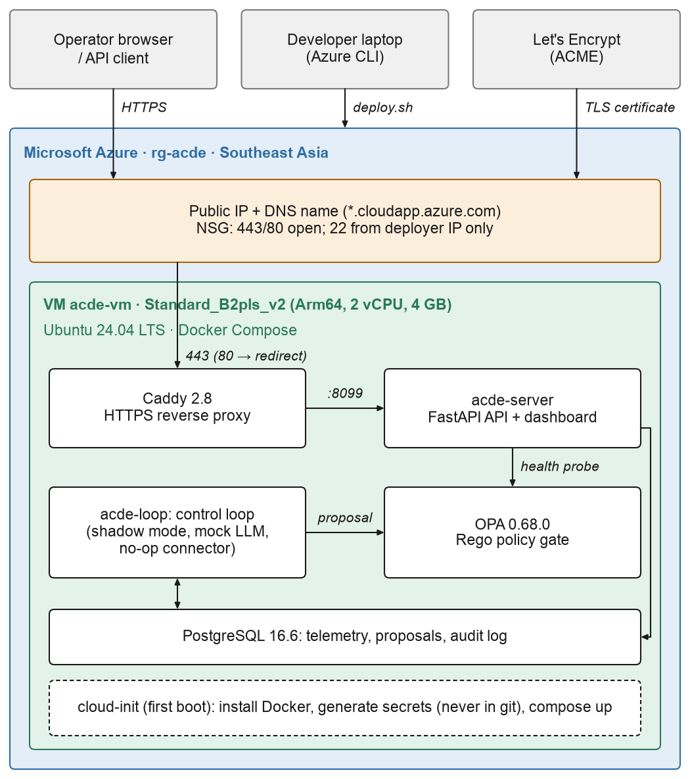
Figure 2: Reference cloud deployment on Microsoft Azure (health-checked, not used for the experiments)
06
CHAPTER SIX
6. TESTING AND VALIDATION
6.1 Testing Strategy
Testing combines fast hermetic unit tests, policy unit tests, integration tests against the running stack, static analysis, an adversarial corpus graded by an independent oracle, and paid pilot runs at the real campaign settings. Every unit test runs with the mock model, so the full suite makes no API calls.
6.2 Unit Testing
The unit suite contains 752 tests in 68 test files and covers 95.38% of the package, above the enforced 80% threshold. A single guard makes any unmocked database access fail immediately instead of waiting for a connection timeout.
6.3 Policy Testing
Each Rego policy has a companion test file; 24 policy unit tests cover the rate limit, cost budget, recovery approval, schema compatibility, the default escalation, and policy coverage.
6.4 Integration Testing
Integration tests run against the containerized stack and exercise the data plane, telemetry, the policy engine, the executor, and the chaos scenarios end to end.
6.5 Static Analysis
ruff enforces linting and formatting with a line length of 100, and mypy checks the full type annotations of all 104 source modules.
6.6 Adversarial Validation
The generated corpus of 5547 cases probes the policy layer with an exhaustive boundary grid, attacker-controlled parameter extremes, hostile strings, illegal proposals sent directly to the policy engine, and a seeded fuzz. Its first pass exposed two contract-layer gaps (budget-legal zero or negative scaling targets, and non-numeric targets that raised inside the gate), both fixed before the final measurement in Chapter 7.
6.7 Pilot Runs
An eight-run pilot at the real timings found that the provider had retired the configured monitoring model (HTTP 410) and exposed a cache-poisoning defect in the accounting; both were fixed before the campaign.
Table 8: Summary of testing activities
Activity | Scope | Result
Unit tests | 752 tests, 68 files | All pass; 95.38% coverage
Policy tests | 24 Rego tests | All pass
Static analysis | ruff and mypy, 104 modules | No issues
Adversarial corpus | 5547 cases | Agreement 5547/5547 after fixes
Live campaign | 560 runs, three arms | No aborts, no token-ceiling breaches

07
CHAPTER SEVEN
7. RESULTS AND DISCUSSION
7.1 Experimental Setup
The campaign comprises 560 runs in three arms: arm A with the live-model agent configurations (240 runs), arm B with the non-agent configurations (240 runs), and arm C with the full configuration under a deterministic mock (80 runs). The baselines and the full system have 80 runs each across the four scenarios, and the ablations have half as many. The testbed and the fixed parameters are listed in Section 3.4. All comparisons are exploratory; the campaign was not pre-registered.
7.2 RQ1: Comparison with Static Orchestration
KEY FINDING: RQ1
Mixed. With a live model, full reduces MTTR by 38% and cost by 56% against static orchestration, but it increases manual interventions by 500%.

Table 9: Medians [IQR] per configuration, pooled across scenarios
Config | LLM | n | MTTR (s) | Cost | Manual interv. | Decision correct
baseline | none | 80 | 378 [244] | 158 [113] | 1.00 [0] | 0 [0]
rule_based | none | 80 | 30.0 [15.9] | 158 [113] | 0 [0.250] | 0 [0]
autoscale | none | 80 | 52.4 [359] | 82.5 [122] | 0.500 [1.00] | 0 [0]
monitor_only | live | 40 | 359 [210] | 1,223 [525] | 1.00 [1.00] | 0 [0]
recovery_only | live | 40 | 220 [75.0] | 1,223 [630] | 6.00 [1.00] | 0 [0]
optimization_only | live | 40 | 267 [360] | 76.5 [128] | 1.00 [1.00] | 0 [0.250]
schema_only | live | 40 | 315 [353] | 920 [122] | 1.00 [1.25] | 0 [0.250]
full | live | 80 | 235 [143] | 69.8 [35.1] | 6.00 [8.00] | 0 [1.00]

With a live model, full changes MTTR from 378 s to 235 s (−38%, Cliff's δ = −0.56) and cost from 158 to 69.8 units (−56%). Both effects are significant after Holm correction. Most of the cost reduction, however, comes from the assumed provisioning term of Eq. (4.4) rather than from metered compute. Manual interventions move the other way: the median rises from 1.00 to 6.00 (500%), the reverse of the base proposal's claimed reduction. The answer to RQ1 is therefore mixed.
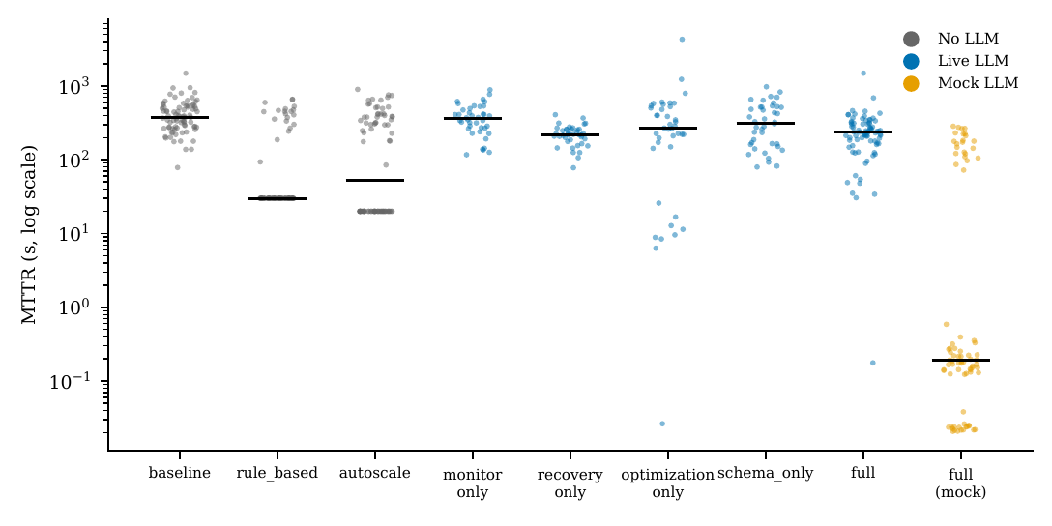
Figure 3: Recovery-time distribution by configuration (log scale)
Table 10: Effect of each configuration against baseline (bootstrap 95% CI, Cliff's δ, Holm-corrected p)
Config | Metric | Δ median [95% CI] | Cliff's δ [95% CI] | p (Holm)
rule_based | MTTR (s) | −348 [−419, −303] | −0.73 [−0.85, −0.60] | <0.001*
autoscale | MTTR (s) | −326 [−406, −82.7] | −0.49 [−0.63, −0.32] | <0.001*
monitor_only | MTTR (s) | −19.2 [−99.6, 59.8] | −0.09 [−0.32, 0.13] | 1.000
recovery_only | MTTR (s) | −159 [−229, −105] | −0.70 [−0.83, −0.55] | <0.001*
optimization_only | MTTR (s) | −111 [−188, 15.9] | −0.27 [−0.50, −0.025] | 0.134
schema_only | MTTR (s) | −63.1 [−182, 87.4] | −0.19 [−0.42, 0.056] | 0.638
full | MTTR (s) | −143 [−212, −94.7] | −0.56 [−0.70, −0.42] | <0.001*
rule_based | Cost (units) | 0 [0, 0] | 0.00 [−0.14, 0.14] | 1.000
autoscale | Cost (units) | −75.0 [−75.0, −75.0] | −0.62 [−0.76, −0.45] | <0.001*
monitor_only | Cost (units) | 1,065 [1,065, 1,074] | 1.00 [1.0, 1.0] | <0.001*
recovery_only | Cost (units) | 1,065 [1,065, 1,389] | 1.00 [1.0, 1.0] | <0.001*
optimization_only | Cost (units) | −81.0 [−81.0, −48.3] | −0.47 [−0.72, −0.20] | <0.001*
schema_only | Cost (units) | 763 [750, 763] | 1.00 [1.0, 1.0] | <0.001*
full | Cost (units) | −87.7 [−96.2, −87.7] | −0.66 [−0.81, −0.51] | <0.001*
rule_based | Manual interv. | −1.00 [−1.00, −1.00] | −0.75 [−0.85, −0.65] | <0.001*
autoscale | Manual interv. | −0.500 [−1.00, 0] | −0.50 [−0.61, −0.39] | <0.001*
monitor_only | Manual interv. | 0 [0, 0] | 0.28 [0.15, 0.42] | <0.001*
recovery_only | Manual interv. | 5.00 [5.00, 5.50] | 0.97 [0.93, 1.0] | <0.001*
optimization_only | Manual interv. | 0 [0, 1.00] | 0.20 [−0.050, 0.42] | 0.121
schema_only | Manual interv. | 0 [0, 0] | 0.25 [0.12, 0.38] | <0.001*
full | Manual interv. | 5.00 [5.00, 8.00] | 0.79 [0.70, 0.88] | <0.001*
rule_based | Decision correct | 0 [0, 0] | 0.00 [0, 0] | 1.000
autoscale | Decision correct | 0 [0, 0] | 0.00 [0, 0] | 1.000
monitor_only | Decision correct | 0 [0, 0] | 0.00 [0, 0] | 1.000
recovery_only | Decision correct | 0 [0, 0] | 0.00 [0, 0] | 1.000
optimization_only | Decision correct | 0 [0, 0] | 0.25 [0.12, 0.38] | <0.001*
schema_only | Decision correct | 0 [0, 0] | 0.25 [0.12, 0.38] | <0.001*
full | Decision correct | 0 [0, 1.00] | 0.42 [0.31, 0.54] | <0.001*

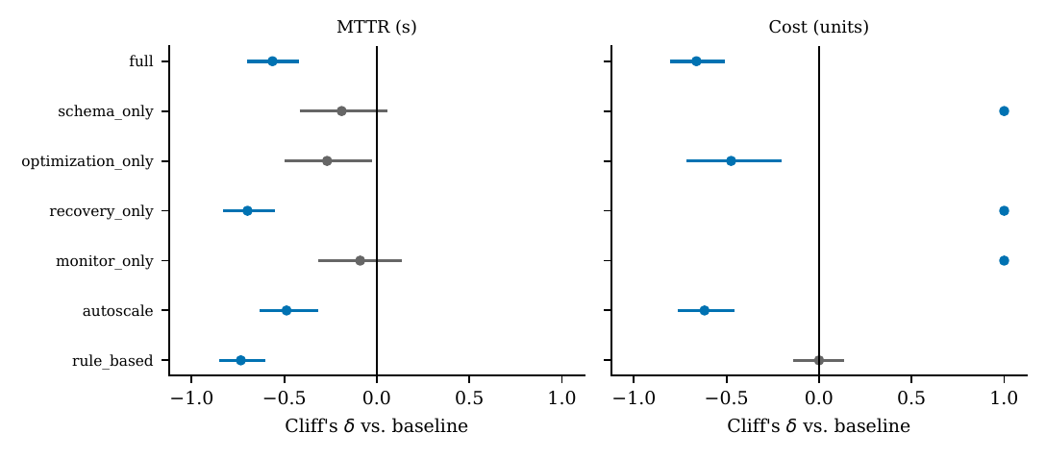
Figure 4: Cliff's δ against baseline by configuration and metric
7.3 RQ2: Comparison with Non-LLM Automation
KEY FINDING: RQ2
No. Two idealized non-LLM baselines recover faster than every agent configuration and keep manual interventions flat or lower.

The two non-LLM comparators call no model, yet both beat every agent configuration on MTTR: rule_based reaches 30.0 s (−92%) and autoscale 52.4 s (−86%), against −38% for full. Both keep manual interventions flat or reduce them. Because their latencies are modelled (30 s and 20 s), they represent idealized automation; still, for these scenarios cheap automation beats the LLM-driven system on speed and on manual interventions.
7.4 RQ3: Decision Quality
KEY FINDING: RQ3
Partly. full executes an accepted mitigation in 0.42 of its runs, which no non-agent configuration can do, but fewer than half of its runs act correctly.

Against an all-zero comparator, Cliff's δ equals the success rate, so full executes an accepted mitigation in 0.42 of its runs. This is the one metric on which the live system achieves something the non-agent configurations cannot, but fewer than half of its runs act correctly.
7.5 Per-Scenario Behaviour
Table 11: Median MTTR (s) by configuration and scenario
Config | ingress_burst | resource_contention | schema_drift | upstream_delay
baseline | 352 | 386 | 424 | 353
rule_based | 30.0 | 30.0 | 433 | 30.0
autoscale | 20.0 | 20.0 | 363 | 393
monitor_only | 366 | 412 | 320 | 275
recovery_only | 223 | 183 | 224 | 248
optimization_only | 10.5 | 267 | 502 | 281
schema_only | 453 | 343 | 120 | 553
full | 148 | 318 | 214 | 237

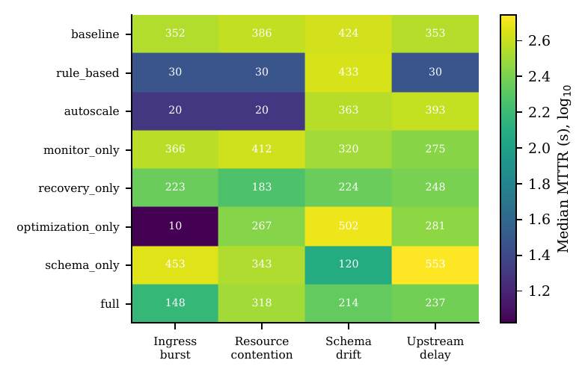
Figure 5: MTTR by configuration and scenario
No single configuration dominates every fault type. optimization_only is the fastest configuration on ingress_burst but slower than baseline on schema_drift, while schema_only shows the mirror-image pattern: a single agent helps where it owns the fault and adds overhead elsewhere.
7.6 RQ4: Mock Versus Live Evaluation
KEY FINDING: RQ4
Yes, decisively. Under a deterministic mock, MTTR falls by a factor of 1219 and the correct-mitigation score rises to 1.00. A mock evaluation is a different and far more flattering experiment.

Table 12: Live model versus deterministic mock for the full configuration
Metric | Live | Mock | Cliff's δ [95% CI] | p (Holm)
MTTR (s) | 235 | 0.193 | 0.81 [0.72, 0.90] | <0.001
Cost (units) | 69.8 | 833 | −0.82 [−0.92, −0.71] | <0.001
Manual interv. | 6.00 | 0 | 0.87 [0.79, 0.93] | <0.001
Decision correct | 0 | 1.00 | −0.57 [−0.69, −0.46] | <0.001
Freshness (s) | 14.0 | 0.0801 | 0.25 [0.074, 0.42] | 0.004

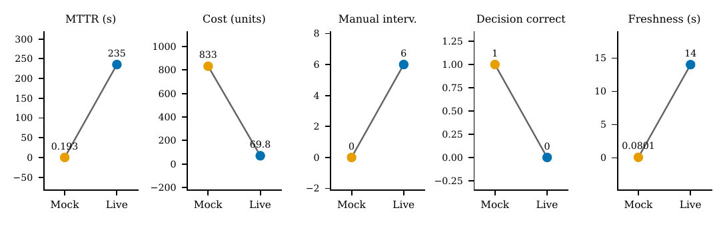
Figure 6: Live versus mock medians for the full configuration, per metric
Under the mock, MTTR falls from 235 s to 0.193 s, a divergence ratio of 1219, and the median correct-mitigation score rises to 1.00, whereas the live rate is 0.42. The mock is therefore not a noisier stand-in for the live system but a far more flattering experiment. Cost moves the other way (69.8 live against 833 mock units); much of that gap reflects harness state carried between runs rather than the model, so it is not interpreted as a model effect.
7.7 LLM Accounting
Table 13: LLM accounting per agent configuration
Config | Calls | Cache hits | Degraded | Invalid | API tokens | Latency (s) | Degraded %
monitor_only | 1.00 | 143 | 0 | 0 | 1,244 | 4.37 | 0%
recovery_only | 2.00 | 262 | 0 | 0 | 2,737 | 10.5 | 0%
optimization_only | 2.00 | 258 | 0 | 0 | 2,998 | 9.22 | 0%
schema_only | 2.00 | 274 | 0 | 0 | 2,550 | 5.73 | 0%
full | 4.00 | 214 | 0 | 0 | 5,946 | 15.0 | 0%

Across the 240 live runs the agents made 703 real calls and used 975,570 tokens; the largest run used 16,042 tokens and 11 calls, far below the caps. Degraded and invalid outputs were zero throughout the campaign.
7.8 Sensitivity Analysis
Table 14: Closed-form break-even points for human latency and static provisioning
Config | MTTR (s) | Human break-even (s) | Cost reduction (%) | Static break-even
autoscale | 52.4 | 49.9 | 47.6 | 3.00
full | 235 | 224 | 55.7 | 2.15
monitor_only | 359 | 342 | −676 | –
optimization_only | 267 | 254 | 51.4 | 2.60
recovery_only | 220 | 209 | −676 | –
rule_based | 30.0 | 28.5 | 0 | –
schema_only | 315 | 300 | −484 | –

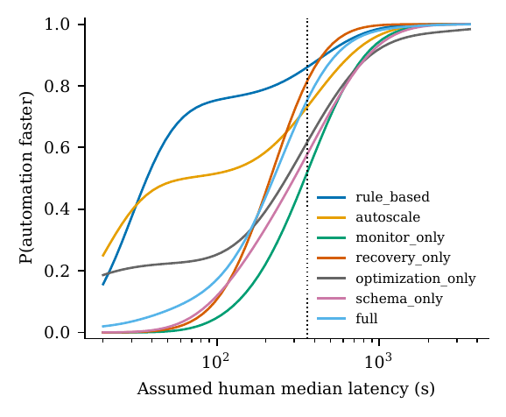
Figure 7: Probability that automation recovers faster than the simulated human
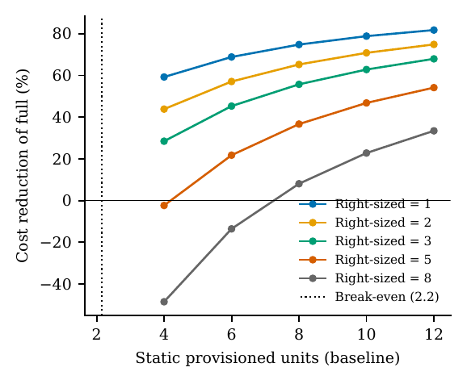
Figure 8: Cost reduction of the full configuration versus static provisioning
full continues to beat the simulated human down to a median human latency of 224 s, against 28.5 s for rule_based, and its cost reduction holds down to a static provisioning level of 2.15 units. The headline numbers therefore depend on modelling choices, which are reported with each result.
7.9 RQ5: Adversarial Containment
KEY FINDING: RQ5
Yes, after two contract fixes. Graded by an independent oracle, the policy contains 3867/3867 unsafe proposals and agrees with the oracle on all 5547 cases.

Table 15: Adversarial corpus graded against the independent oracle
Category | Cases | Containment [Wilson 95%] | Over-block | Oracle agreement | Fail-open
boundary_grid | 4320 | 3056/3056 [0.9987, 1.0000] | 0/1264 [0.0000, 0.0030] | 4320/4320 [0.9991, 1.0000] | 0
defense_in_depth | 133 | 133/133 [0.9719, 1.0000] | – | 133/133 [0.9719, 1.0000] | 0
fuzz | 1000 | 606/606 [0.9937, 1.0000] | 0/394 [0.0000, 0.0097] | 1000/1000 [0.9962, 1.0000] | 0
injection | 28 | 28/28 [0.8794, 1.0000] | – | 28/28 [0.8794, 1.0000] | 0
param_extremes | 66 | 44/44 [0.9197, 1.0000] | 0/22 [0.0000, 0.1487] | 66/66 [0.9450, 1.0000] | 0
Overall | 5547 | 3867/3867 [0.9990, 1.0000] | 0/1680 [0.0000, 0.0023] | 5547/5547 [0.9993, 1.0000] | 0

Overall containment is 3867/3867 (Wilson lower bound 0.9990), the over-block rate on legal proposals is zero, and the policy agrees with the oracle on all 5547 cases. A newer policy-engine release mis-evaluated some floating-point budget comparisons, so the engine version is pinned.
7.10 Lessons Learned
- Concurrency: versioned partition creation raced under concurrent callers until it was serialized behind an advisory lock.
- Audit trail: writing the audit row after execution could lose an action; the intent row is now committed first.
- Detection: the anomaly detector had no callers in production paths until it was wired into the monitoring agent.
- Taxonomies: decision scoring needed an explicit mapping from live fault types to the experiment's scenario names.
- Hermetic tests: a recurring unmocked-database failure was fixed once at its mechanism instead of four times by instance.
- Adversarial testing: the corpus exposed two contract gaps and an engine-version dependence.
- Pilots: a short paid pilot found a retired model on its first call.
7.11 Limitations
- A single host, synthetic data with injected faults, and a simulated on-call engineer.
- One live model family; the cross-model sweep was not run.
- Non-LLM baselines are modelled with fixed latencies rather than deployed.
- Agents start the MTTR clock at detection while non-agent configurations detect at injection, which favours the agents.
- The metered cost term is integrated over unequal windows, and pool and worker state were not reset between runs.
- The trust core and the enterprise governance layer were not exercised.
08
CHAPTER EIGHT
8. CONCLUSION AND FUTURE WORK
8.1 Conclusion
This project implemented a seven-layer, policy-bounded agentic framework for cloud data pipeline governance and evaluated it with a live model, explicit non-LLM baselines, an adversarial corpus graded by an independent oracle, and closed-form sensitivity analyses. The design holds up only in part: it reduces recovery time by less than the base proposal claimed, it reduces cost mainly through an assumed provisioning gap, it increases manual interventions, and idealized non-LLM automation recovers faster still. The most consequential result concerns evaluation itself: the same configuration supports very different conclusions under a deterministic mock and under a live model. For this class of system, the evaluation path behind a number matters as much as the number, and mock and live results should be reported as separate findings.
8.2 Future Work
- Run the cross-model sweep against at least two live providers to test the claim of model independence.
- Exercise the trust core's mode transitions and measure kill-switch latency under load.
- Re-run the cost comparison with per-run state reset and a fixed measurement window.
- Replace the modelled baselines with deployed controllers and evaluate on real production traces.
- Replace the static agent-priority bid with an explicit negotiation protocol and extend the evaluation to multi-cloud deployments and formal verification of the policy layer.
REFERENCES
[1] H. Foidl, V. Golendukhina, R. Ramler, and M. Felderer, “Data pipeline quality: Influencing factors, root causes of data-related issues, and processing problem areas for developers,” J. Syst. Softw., vol. 207, p. 111855, 2024, doi: 10.1016/j.jss.2023.111855.
[2] Y. Chen et al., “Automatic root cause analysis via large language models for cloud incidents,” in Proc. 19th Eur. Conf. Comput. Syst. (EuroSys), 2024, pp. 674–688, doi: 10.1145/3627703.3629553.
[3] Z. Wang et al., “RCAgent: Cloud root cause analysis by autonomous agents with tool-augmented large language models,” in Proc. 33rd ACM Int. Conf. Inf. Knowl. Manage. (CIKM), 2024, pp. 4966–4974, doi: 10.1145/3627673.3680016.
[4] Y. Luo et al., “OpsAgent: An evolving multi-agent system for incident management in microservices,” arXiv:2510.24145, 2025, doi: 10.48550/arXiv.2510.24145.
[5] A. M. Kirubakaran et al., “Governing cloud data pipelines with agentic AI,” arXiv:2512.23737, 2025, doi: 10.48550/arXiv.2512.23737.
[6] X. Liu, T. Chen, W. Li, X. Hu, and H. Wei, “The sim-to-real gap of foundation model agents: A unified MDP perspective,” arXiv:2606.07017, 2026, KDD 2026 Blue Sky Ideas Track, doi: 10.48550/arXiv.2606.07017.
[7] M. Zhu et al., “RealUserSim: Bridging the reality gap in agent benchmarking via grounded user simulation,” arXiv:2605.20204, 2026, doi: 10.48550/arXiv.2605.20204.
[8] A. Gupta, “ReliabilityBench: Evaluating LLM agent reliability under production-like stress conditions,” arXiv:2601.06112, 2026, doi: 10.48550/arXiv.2601.06112.
[9] K. Rzadca et al., “Autopilot: Workload autoscaling at Google,” in Proc. 15th Eur. Conf. Comput. Syst. (EuroSys), 2020, doi: 10.1145/3342195.3387524.
[10] E. Debenedetti, J. Zhang, M. Balunović, L. Beurer-Kellner, M. Fischer, and F. Tramèr, “AgentDojo: A dynamic environment to evaluate prompt injection attacks and defenses for LLM agents,” in Proc. Adv. Neural Inf. Process. Syst. (NeurIPS), Datasets and Benchmarks Track, 2024, doi: 10.48550/arXiv.2406.13352.
[11] H. Zhang et al., “Agent security bench (ASB): Formalizing and benchmarking attacks and defenses in LLM-based agents,” in Proc. 13th Int. Conf. Learn. Represent. (ICLR), 2025, doi: 10.48550/arXiv.2410.02644.
[12] A. Joshi, T. Finin, K. P. Joshi, and L. Kagal, “Deontic policies for runtime governance of agentic AI systems,” arXiv:2606.19464, 2026, doi: 10.48550/arXiv.2606.19464.
[13] A. C. Sanna, “Cross-LLM generalization of behavioral backdoor detection in AI agent supply chains,” arXiv:2511.19874, 2025, doi: 10.48550/arXiv.2511.19874.
[14] L. Zhang, Y.-Y. Chu, and R. Krishnan, “Toward agentic governance: What shapes LLM-agent intervention in public forums?” arXiv:2606.00603, 2026, doi: 10.48550/arXiv.2606.00603.
[15] S. Yao et al., “ReAct: Synergizing reasoning and acting in language models,” in Proc. 11th Int. Conf. Learn. Represent. (ICLR), 2023, doi: 10.48550/arXiv.2210.03629.
[16] F. F. Xu et al., “TheAgentCompany: Benchmarking LLM agents on consequential real world tasks,” arXiv:2412.14161, 2024, doi: 10.48550/arXiv.2412.14161.
[17] J. Rystrøm, C. Schmitz, K. Korgul, J. Batzner, and C. Russell, “Agent benchmarks fail public sector requirements,” arXiv:2601.20617, 2026, doi: 10.48550/arXiv.2601.20617.
[18] D. Hadfield-Menell, A. Dragan, P. Abbeel, and S. Russell, “The off-switch game,” in Proc. 26th Int. Joint Conf. Artif. Intell. (IJCAI), 2017, pp. 220–227, doi: 10.24963/ijcai.2017/32.
[19] H. Zheng, Q. Dong, R. K. Depena, J. D. Bhatia, F. Xiao, and P. Xu, “Separating capability from permission: A governance framework for agentic AI autonomy levels,” arXiv:2607.23438, 2026, doi: 10.48550/arXiv.2607.23438.
[20] Cloud Native Computing Foundation, “Open Policy Agent: policy-based control for cloud native environments,” https://www.openpolicyagent.org, 2016, accessed 2026-09-21.
[21] K. Zhang, Y. Peng, K. Jiang, and Y. Zhang, “ActGov: Governing LLM agent actions via policy-constrained validation,” arXiv:2609.24446, 2026, doi: 10.48550/arXiv.2609.24446.
[22] Y. Chen et al., “AIOpsLab: A holistic framework to evaluate AI agents for enabling autonomous clouds,” arXiv:2501.06706, 2025, doi: 10.48550/arXiv.2501.06706.
[23] J. Barnes, “OpenSec: Measuring incident response agent calibration under adversarial evidence,” arXiv:2601.21083, 2026, doi: 10.48550/arXiv.2601.21083.
[24] A. Basiri et al., “Chaos engineering,” IEEE Software, vol. 33, no. 3, pp. 35–41, 2016, doi: 10.1109/MS.2016.60.
[25] B. Efron, “Bootstrap methods: Another look at the jackknife,” Ann. Statist., vol. 7, no. 1, 1979, doi: 10.1214/aos/1176344552.
[26] H. B. Mann and D. R. Whitney, “On a test of whether one of two random variables is stochastically larger than the other,” Ann. Math. Statist., vol. 18, no. 1, pp. 50–60, 1947, doi: 10.1214/aoms/1177730491.
[27] F. Wilcoxon, “Individual comparisons by ranking methods,” Biometrics Bull., vol. 1, no. 6, p. 80, 1945, doi: 10.2307/3001968.
[28] S. Holm, “A simple sequentially rejective multiple test procedure,” Scand. J. Statist., vol. 6, no. 2, pp. 65–70, 1979.
[29] N. Cliff, “Dominance statistics: Ordinal analyses to answer ordinal questions,” Psychol. Bull., vol. 114, no. 3, pp. 494–509, 1993, doi: 10.1037/0033-2909.114.3.494.
[30] E. B. Wilson, “Probable inference, the law of succession, and statistical inference,” J. Amer. Statist. Assoc., vol. 22, no. 158, pp. 209–212, 1927, doi: 10.1080/01621459.1927.10502953.
APPENDIX A: REPRODUCTION GUIDE
The complete source code, policies, per-run campaign data, and artifact generators are available at https://github.com/bodapatisaikrishna/agentic-cloud-pipeline-governance. The following commands reproduce the environment and the paper artifacts:
git clone https://github.com/bodapatisaikrishna/agentic-cloud-pipeline-governance.git
cd agentic-cloud-pipeline-governance
uv sync # install dependencies
cp .env.example .env # configure (mock LLM by default)
make lint && make test-unit # static analysis and 752 unit tests
make opa-test # policy unit tests
make up # start PostgreSQL, Redpanda, Airflow, OPA
make experiment-smoke # short mock experiment
make paper-repro-quick # regenerate tables, figures, and the paper PDF
The live campaign (make campaign MAX_TOKENS=...) requires an API key for an OpenAI-compatible endpoint and runs for about two days on a single machine.

